



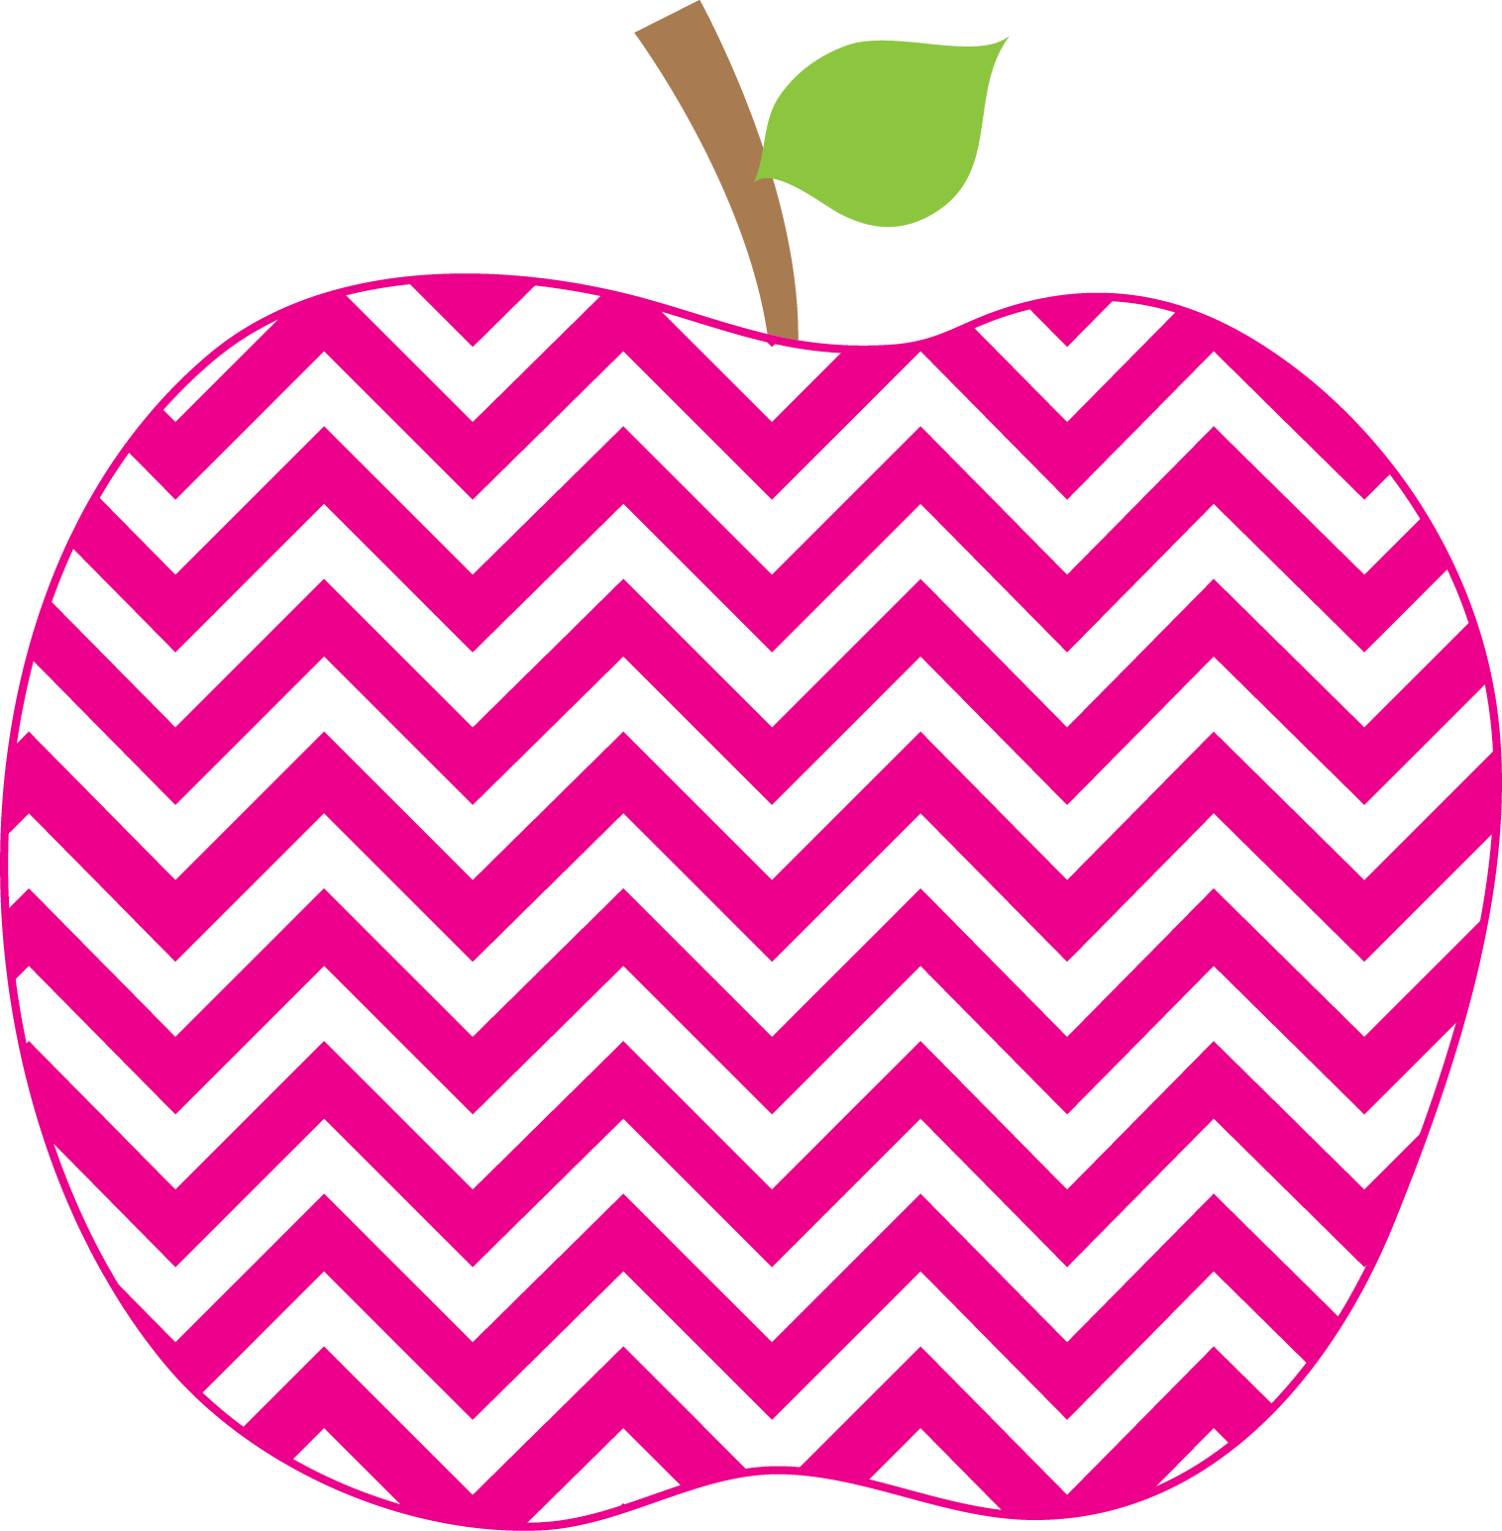

Weekly News

MRS. HOLLOWAY’S CLASS Sept 26th SSept.12t19Sep16th

Literacy- I am currently doing Phonological Awareness Assessments and groups will be set up once I have analyzed the data.

The sight words for the week are: are, they, with, be, and his

Reviewing the name of, sound of and formation of p and h.

The word family we will review is “it” family.

The Reading Strategy for the week is LIPS THE FISH
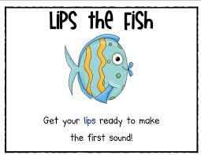

Writing- We will continue to talk about the Write Trait,”Ideas”. I have been talking about an idea being like a seed, and it will grow as we add more detail to our writing.

Math- Pattern assessments were sent home to be signed. We have started on our Numbers to 20 Unit. Our Math lead assigned to our school is Nicole Holloway, and she will be in and out of classes working with groups and whole class activities.

YYWorld –How do seasonal changes affect animals and people will be our topic for the next few weeks.
Learning Focus for the Week

This is school Safety Week. We will be practicing Fire Drill, Lock Down, Bus Safety and School Evacuation.

Please make sure that the RED reading folders and WEEKLY News are returned on THURSDAY of each week. This is the day the students read their book to a peer, and I prepare the folders for the following week. Some are not coming back until Friday or Monday.

Hot Lunch orders are due on the 27th.
Homework
Your child is bringing home two books for Home Reading. After reading have your child do an oral retell. Return on Thursday please. I will be sending home an activity sheet on Numbers to 20 Unit.
Information

